248 FROM BASE 10 TO 2

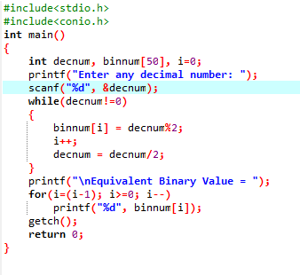

OUTPUT

